**PARALLEL R, L, C**

**CIRCUITS**

**LAB # 05**



**Fall 2022**

**CSE-203L**

**Circuits & System-2 Lab**

Submitted by: **NAVEED AHMAD**

Registration No.: **22PWCSE2165**

Class Section: **B**

“On my honor, as student of University of Engineering and Technology, I have neither given nor received unauthorized assistance on this academic work.”

Student Signature: ______________

Submitted to:

**Engr. Usman Malik**

November 2023

Department of Computer Systems Engineering

University of Engineering and Technology, Peshawar

**Objectives:**

*This exercise delves into the voltage and current dynamics in parallel R, L, C networks. The focus is on understanding phase differences among components, extending Kirchhoff’s Current Law to AC circuits, and generating time domain and phasor plots of currents. Additionally, a technique employing a current sense resistor to measure current will be explored.*

***Theory:***

In parallel R, L, C networks, resistors exhibit in-phase voltage and current, capacitors lag by 90 degrees, and inductors lead by 90 degrees. The unique phase responses create a complex impedance with a phase angle between +90 and -90 degrees. Computation of Kirchhoff’s Current Law involves vector (phasor) sums due to these phase responses. All related calculations, including current division, must be done using vectors.

**Equipment and Components:**

* AC Function Generator
* Oscilloscope
* 10 nF Capacitor
* 10 mH Inductor
* 1 kΩ Resistor
* 10 Ω Resistor

**Circuit and schematic:**

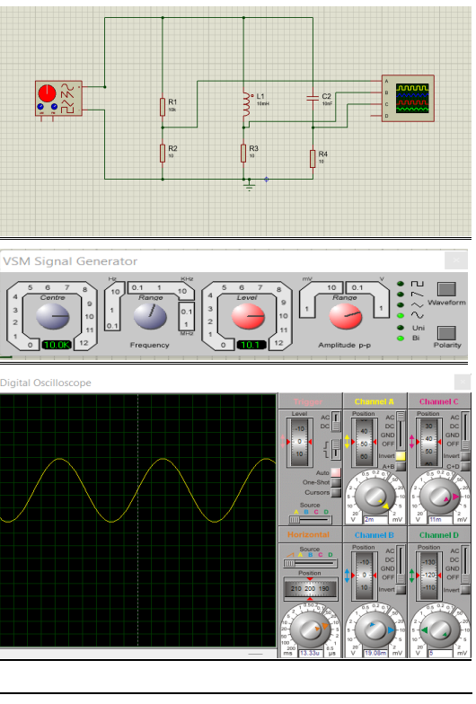

**Procedure:**

Use Figure 1 with a 10 V p-p 10 kHz source, R=1kΩ, C=10nF, and L=10mH to determine theoretical capacitive reactance, inductive reactance, and circuit impedance. Record results in Table 1. Utilize the current divider rule to compute iR, iL, and iC, and record them in Table 2.

Build the circuit with R=1kΩ, L=10mH, and C=10nF. Measure currents using a small current sense resistor. Place a 10Ω resistor between ground and the bottom connection of parallel components.

Measure total current using probe1 across the generator and probe2 across the sense resistor. Record magnitude and phase in Table 2.

Repeat the process for capacitor, resistor, and inductor currents by placing sense resistors accordingly. Record magnitudes and phases in Table 2.

Calculate deviations between theoretical and experimental values in Table 2. Based on experimental values, determine experimental Z, XL, and XC via Ohm’s Law, recording in Table 1 along with deviations.

Create a phasor plot illustrating iin, iC, iL, and iR, showcasing both time domain display and the phasor plot in the technical report.

Repeat the experiment for various C, L, and R values.

**Calculation and observation:**

